Rule 17 is a specific Rule for penalty areas, which are bodies of water or other areas defined by the Committee where a ball is often lost or unable to be played. For one penalty stroke, players may use specific relief options to play a ball from outside the penalty area.

17.1 Options for Ball in Penalty Area
Penalty areas are defined as either red or yellow. This affects the player’s relief options (see Rule 17.1d).
A player may stand in a penalty area to play a ball outside the penalty area, including after taking relief from the penalty area.
Player May Play Ball as It Lies in Penalty Area or Take Penalty Relief :
The player may either:
- Play the ball as it lies without penalty, under the same Rules that apply to a ball in the general area (which means there are no specific Rules limiting how a ball may be played from a penalty area), or
- Play a ball from outside the penalty area by taking penalty relief under Rule 17.1d or 17.2.
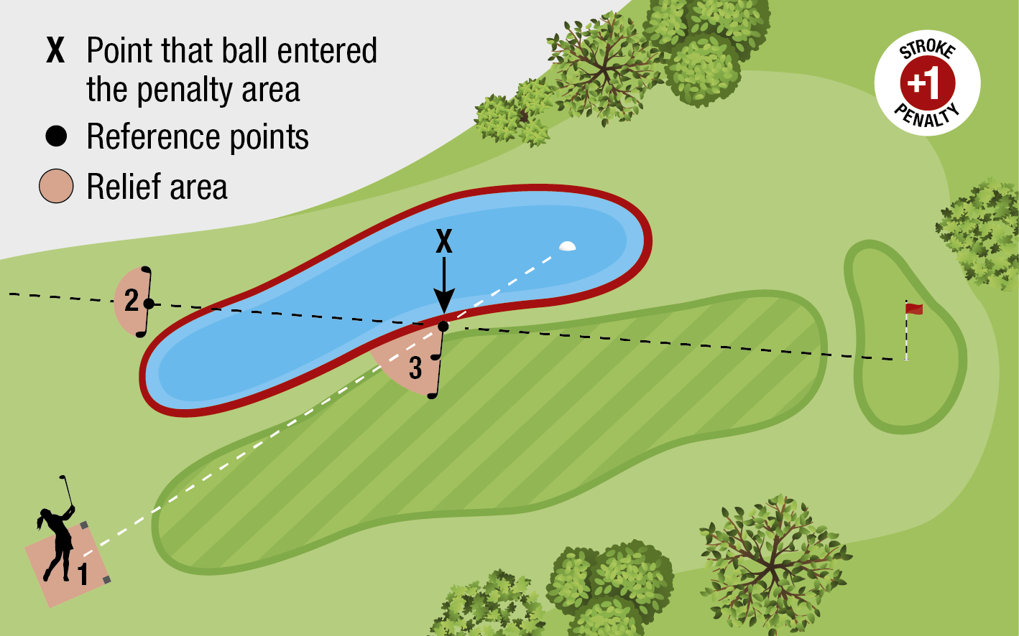
DIAGRAM #2 17.1d: RELIEF FOR BALL IN RED PENALTY AREA
When it is known or virtually certain that a ball is in a red penalty area and the player wishes to take relief, the player has three options, each for one penalty stroke: (1) The player may take stroke-and-distance relief (see point (1) in Diagram #1 17.1d). (2) The player may take back-on-the-line relief (see point (2) in Diagram #1 17.1d). (3) The player may take lateral relief (red penalty area only). The reference point for taking lateral relief is point X, which is the estimated point where the original ball last crossed the edge of the red penalty area. The relief area is two club-lengths from the reference point, is not nearer to the hole than the reference point and may be in any area of the course, except the same penalty area.

