OPENING DAY
28TH JANUARY 2021

PRESIDENT AND CAPTAIN’S TROPHY

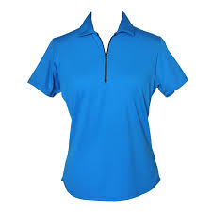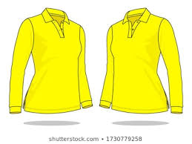
PRESIDENT’S TEAM
CAPTAIN’S TEAM

MAKE SURE YOU KNOW WHICH TEAM YOU ARE ON AND WEAR THE RIGHT COLOUR!!

TEAM LISTS ARE ON THE NOTICEBOARD.
